**Introduction to Enterprise Analytics**

# ALY6050 Module 4 Assignment

# Faculty: Prof. Richard He

# 2020 Winter CPS Quarter

# Image result for neu cps

Shraddha Gopalakrishnan [NUID: 001376444]

**Introduction**

In data mining, once the information is extracted the next step is to make sense out of it. Here enters the process of decision-making; the most important accord in the world of businesses. Big data combined with algorithms to come up with decision making models has improved performance of organizations. [1] Models can be handy and very useful, often making accurate predictions or guiding us with choices that leads to optimized solutions. In fact, this benefits companies to avoid some of the common biases that at times are wrongly judged by the leaders. Information derived from decision-making promotes high-quality choices and reduces the risk and uncertainties associated with decisions. [1]

**Analysis**

Inventories contribute as a huge expenditure for any company which is why managing those is a big task. Excess stock may lead to poor financial management and lack of items can bring a business down. [2] The managers have a hard time dealing with such issues and hence decision making is the key to a firm’s success. There are two parts within this project- first deals with excel calculations and second with R programming.

***Part 1:***

In this section, we are the consultants for finding the right course of action for a manufacturing company’s key engine components.

1. Our given data is the annual demand 16000 units and cost of each unit $77. The supplier cost per order is an uncontrollable input as it depends on different suppliers and the cost is not on the manager to decide. For our case it is given as 225$. The decision variables are quite the interesting parameters. We have opportunity cost (cost incurred with many choices) for a year as 19% i.e. 0.19. Carrying cost which is cost of maintaining the stock is given as $14.63 per unit. Using all this information we go on to figure the larger parameters.
2. Before evaluating the mathematical model, we find the economic order quantity as follows:

EOQ = ((2 * Annual Demand* Ordering Cost) / (Holding Cost))1/2

Our EOQ value is **701.53** which states that the company should reorder the items when only 701 units are left.

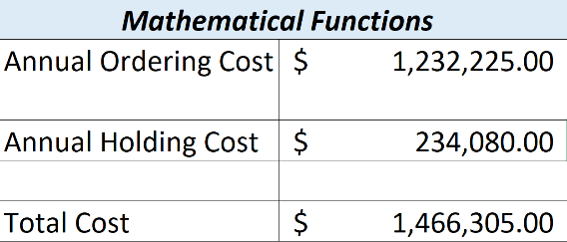

Inventory related costs are approximated at-

Annual Ordering Cost = **$1232225**

Annual Holding Cost = **$234080**

Total Cost = **$1466305**

Table 1: Mathematical Parameters

1. Refer Excel for Calculations
2. In order to find the data table using “What-if Analysis” in Excel, we first type our EOQ 701.53 in the first row of the table. The cost for this quantity is derived as:

((EOQ/2) * Carrying Cost) + (Annual Demand/EOQ) * Supplier Cost

The “What-if Analysis” gives us the cost values for the rest 11 quantities (randomly chosen).

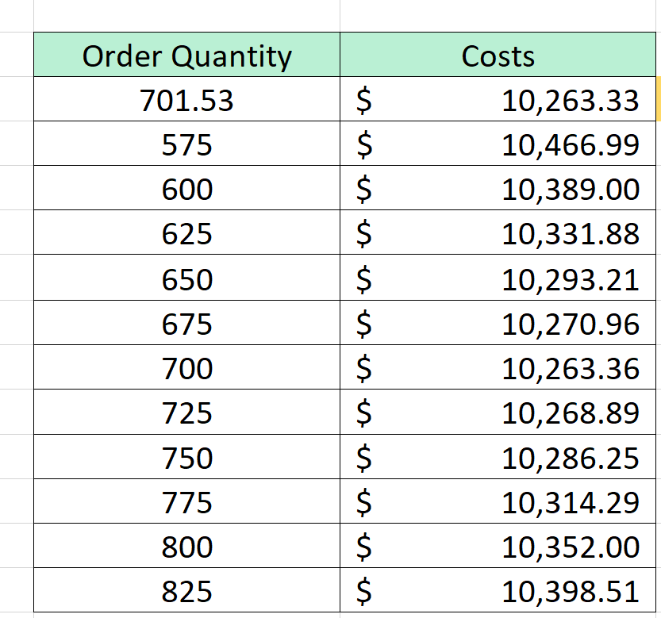

Table 2: Model of What-if Analysis

These values are predictions for total cost the company would have to lend for their corresponding order quantities. Out of these, the quantity with smallest total cost turns out to be the one which is the EOQ.

701.53 ~ 702 is our approximate order quantity.

1. Graphical representation for Total cost vs Order Quantity is:

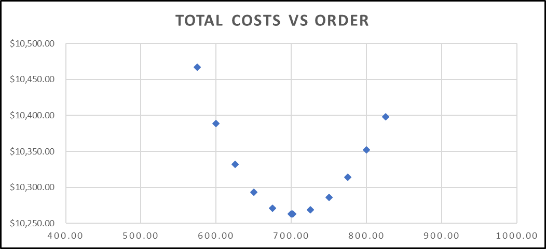The denotes a U-shaped scatter plot which demonstrates that the total cost for quantities in the range of 575-825 initially decreases and then gradually rises. In other words, the interpretation is the relationship between Total Cost and Order quantity is not linear.

Figure 1: Depiction of relativity between Total Cost & Order Quantity

1. Using Excel Solver our result have been correctly verified in the following flow-

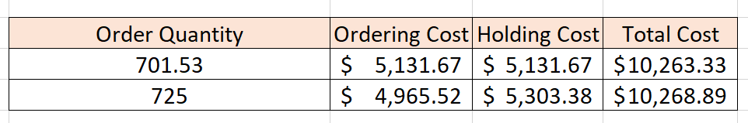

Table 3: Excel Solver

Any random value is considered from the data table, we take 725.

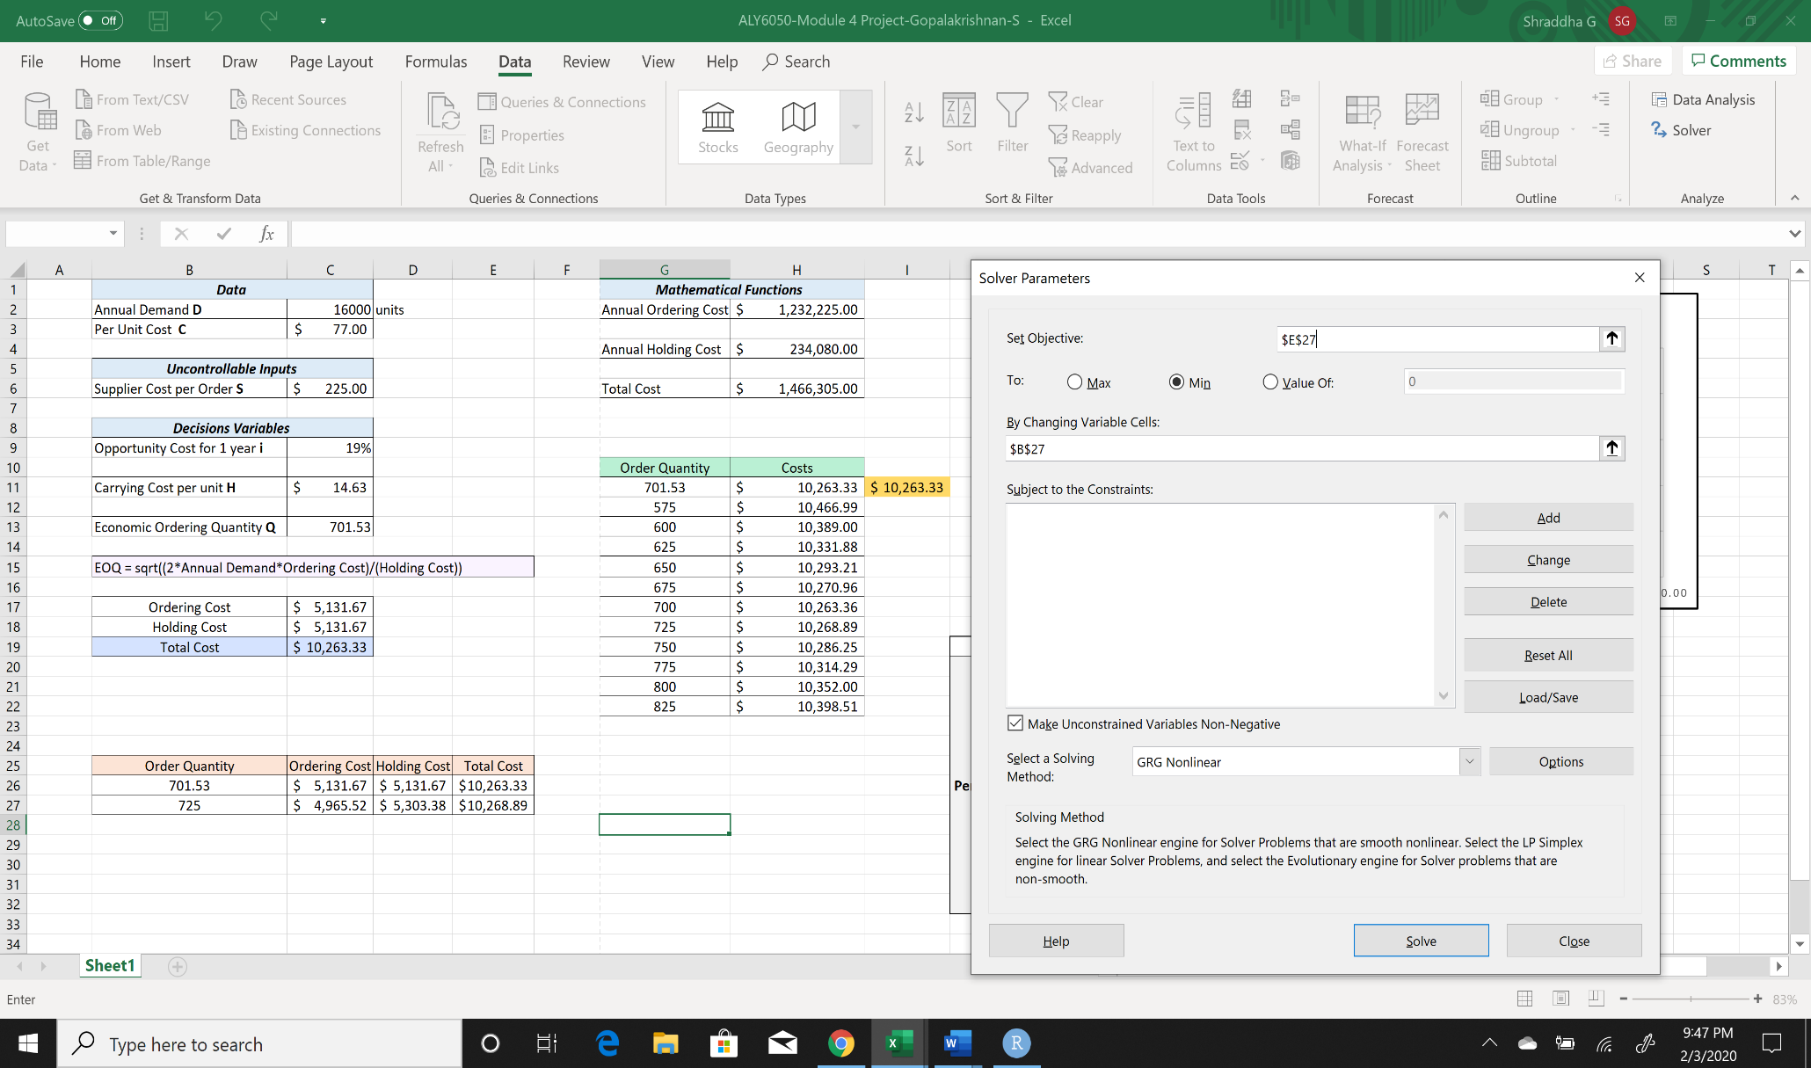

Figure 2: Solver Parameters Selection

The Excel Solver looks like this and set objective is our total cost value and changing variable is our order quantity.

**$E$27** is **$10,268.89**

**$B$27** is **725**

After this we select our solving method as GRG Nonlinear because our graph doesn’t show a linear curve.

Tapping on “Solve”, the outcome obtained is the least cost value with its parallel order quantity statistic.

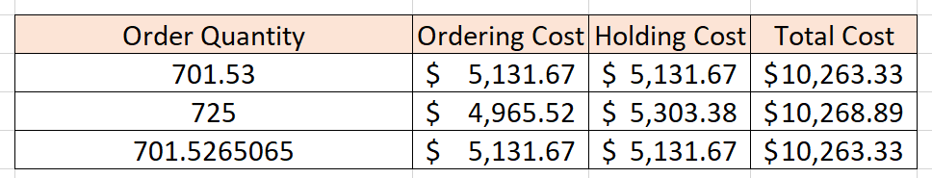

Table 4: Excel Solver Output

Hence our minimal cost value has been verified using the Excel Solver.

1. Next we take 6 random supplier cost values in a row and 12 per unit cost values to procure a 2-way Data table using “What-If-Analysis” in Excel.

The output is shown in the succeeding page.

The sensitivity of total cost with supplier and per unit cost (two of our model parameters) is seen through the output figures in the table.

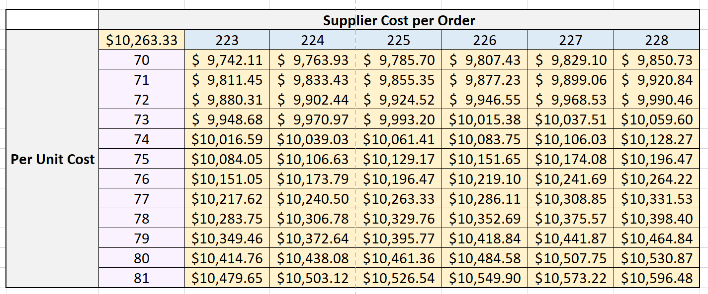

Table 5: What-If-Analysis

1. Analysis to the Vice President of Operations from the part 1 as a Consultant-
2. The total cost increases with increasing supplier cost per order and when the per unit cost boosts. Therefore, Total Cost ∝ Supplier Cost * Per Unit Cost meaning total cost is directly proportional to our model parameters.
3. The graph obtained for total cost versus the order quantity is not linear.
4. When the company has just 702 items left in the stock, it should stipulate more items to save the company from loss and failure.
5. Total minimal cost is predicted as $10,263.33.

***Part 2:***

In this module, we have been asked to assume all specifications to be same as Part 1 and code in R. Part 2 testifies if the annual demand with lower limit 13000, upper limit 18000 and peak 16000 shows triangular distribution.

Initially we declare the variables in R.

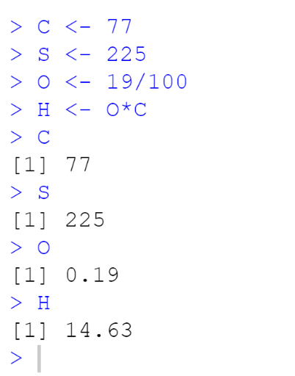Then Triangular probability functions are executed.

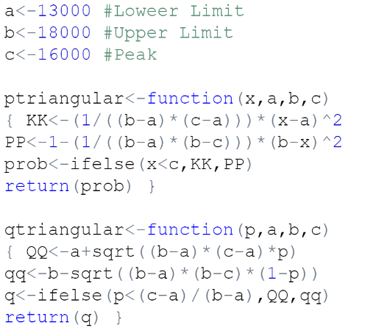

1. We perform simulation of 1000 values to generate random numbers using the below lines of code:

*set.seed(1)*

*rano <-qtriangular(runif(1000),a,b,c)*

*rano*

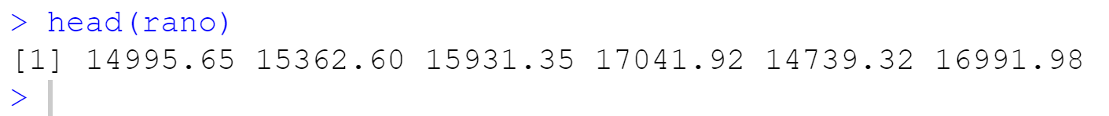

For analyzing sub-questions 2,3,4 we insert the following code:

*total.cost.array <- NULL*

*minimalcost.array <- NULL*

*for (i in rano){*

*minimalcost = (2*i*S)/ (O*C)*

*minimalcost.array = append(minimalcost.array,minimalcost)*

*annual.S = (S*i)/minimalcost*

*avgcost = i/12*

*H.for.i = O*avgcost*

*total.cost = H.for.i + avgcost*

*total.cost.array = append(total.cost.array,total.cost)*

*}*

We create two arrays- one for total cost and other for minimal cost. These arrays are then used for further cost arithmetic. After this, we run both our arrays which yield 1000 cardinals.

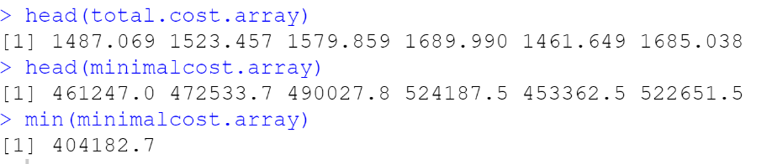

The probability distributions that best fit the minimum total cost, order quantities, and annual number of orders is the *Triangular Probability distribution;* which can be depicted in the 3 screenshots below obtained from R codes:

*hist(total.cost.array,freq=F,main="Distribution of the Simulation of Total Cost")*

*lines(density(total.cost.array),lwd=2,col="grey")*

*hist(minimalcost.array,freq=F,main="Distribution of the Simulation of Order Quantity")*

*lines(density(minimalcost.array),lwd=2,col="orange")*

*hist(rano,freq=F,main="Distribution of the Simulation of Annual Number of Orders")*

*lines(density(rano),lwd=2,col="blue")*

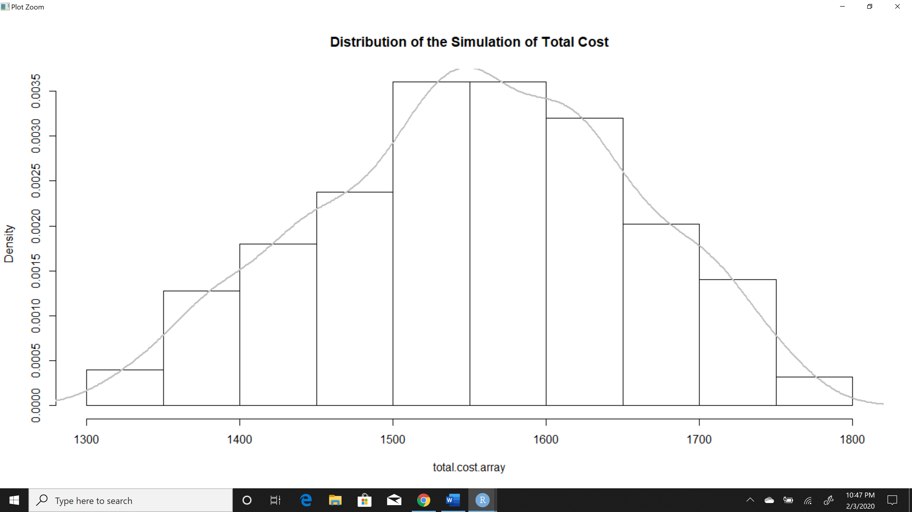

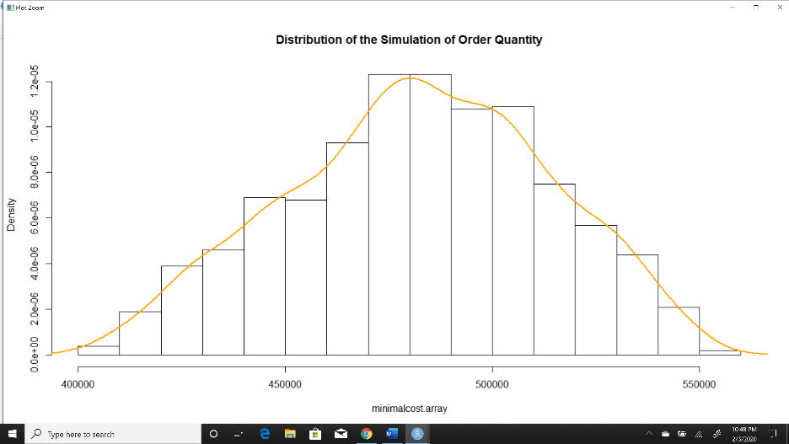

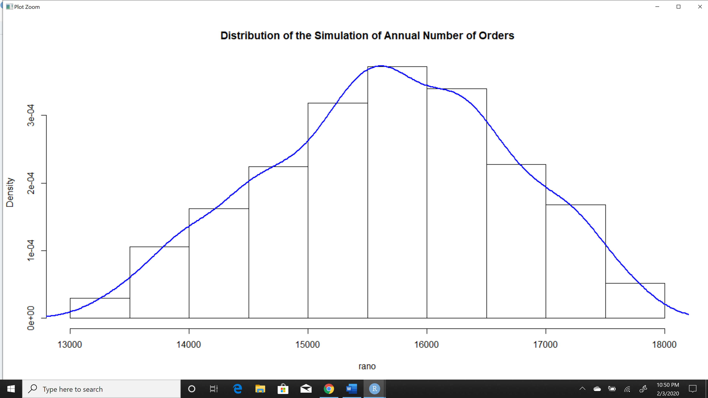

All the three variables can be shown perfectly with the triangular distribution and are slightly skewed to the left. This mean the mean is also to the left of the peak; peak hits a value lesser than 16000 as clearly seen from the 1st and 3rd graph. Same is the case for 2nd graph which has mean value as 482070 and peak as 480000.

**Conclusion**

Data and analytics are allowing managers to understand intricate details of their business, anticipate market shifts and manage risks. [2] Rather than following intuitions for inventory management, marking down solutions, or hiring talents, companies are now relying completely on analytics and numerical logic reasoning to make decisions. Decisions help improve efficiency, risk management and profits. Studies have shown that data driven organizations revel in high operational efficiency, improved customer satisfaction and credit levels. It is no longer a surprise that decision making techniques are now finding a way into workforce, supply-chain and finance and risk strategies at a supervisory level as clearly cultivated from this project. [2]

**References**

[1] Kusiak, A. (1970, January 1). Data mining and decision making: Semantic Scholar. Retrieved from,<https://www.semanticscholar.org/paper/Data-mining-and-decision-making-Kusiak/49a37f0405df52abf41c2af1753e2306c16d714c>

[2] Singh, H. (2018, December 1). Using Analytics for Better Decision-Making. Retrieved from <https://towardsdatascience.com/using-analytics-for-better-decision-making-ce4f92c4a025>